**Exercise 4: Creating and Configuring a Maven Project**

**Directory Structure for Maven Project:**

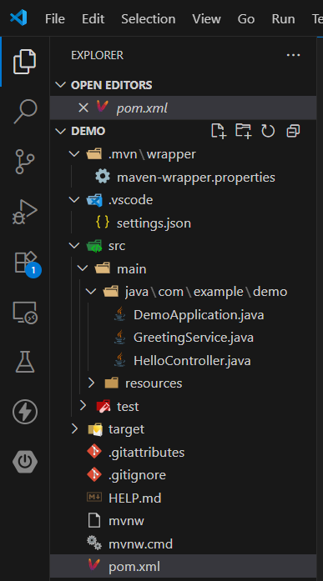

**Running the project:**

**Code:**

package com.example.demo;

import org.springframework.stereotype.Service;

// This marks the class as a Spring-managed service component

@Service

public class GreetingService {

    public String getGreetingMessage() {

        return "Hello from GreetingService!";

    }

    public String getWelcomeMessage() {

        return "Welcome from GreetingService!";

    }

}

**Output:**

